**EXPERIMENT (Magnetics and Motors)** *(25 Marks, 90 Minutes)* **NAME: SOLUTIONS**

**Part 1: Force on a conductor in a magnetic field**

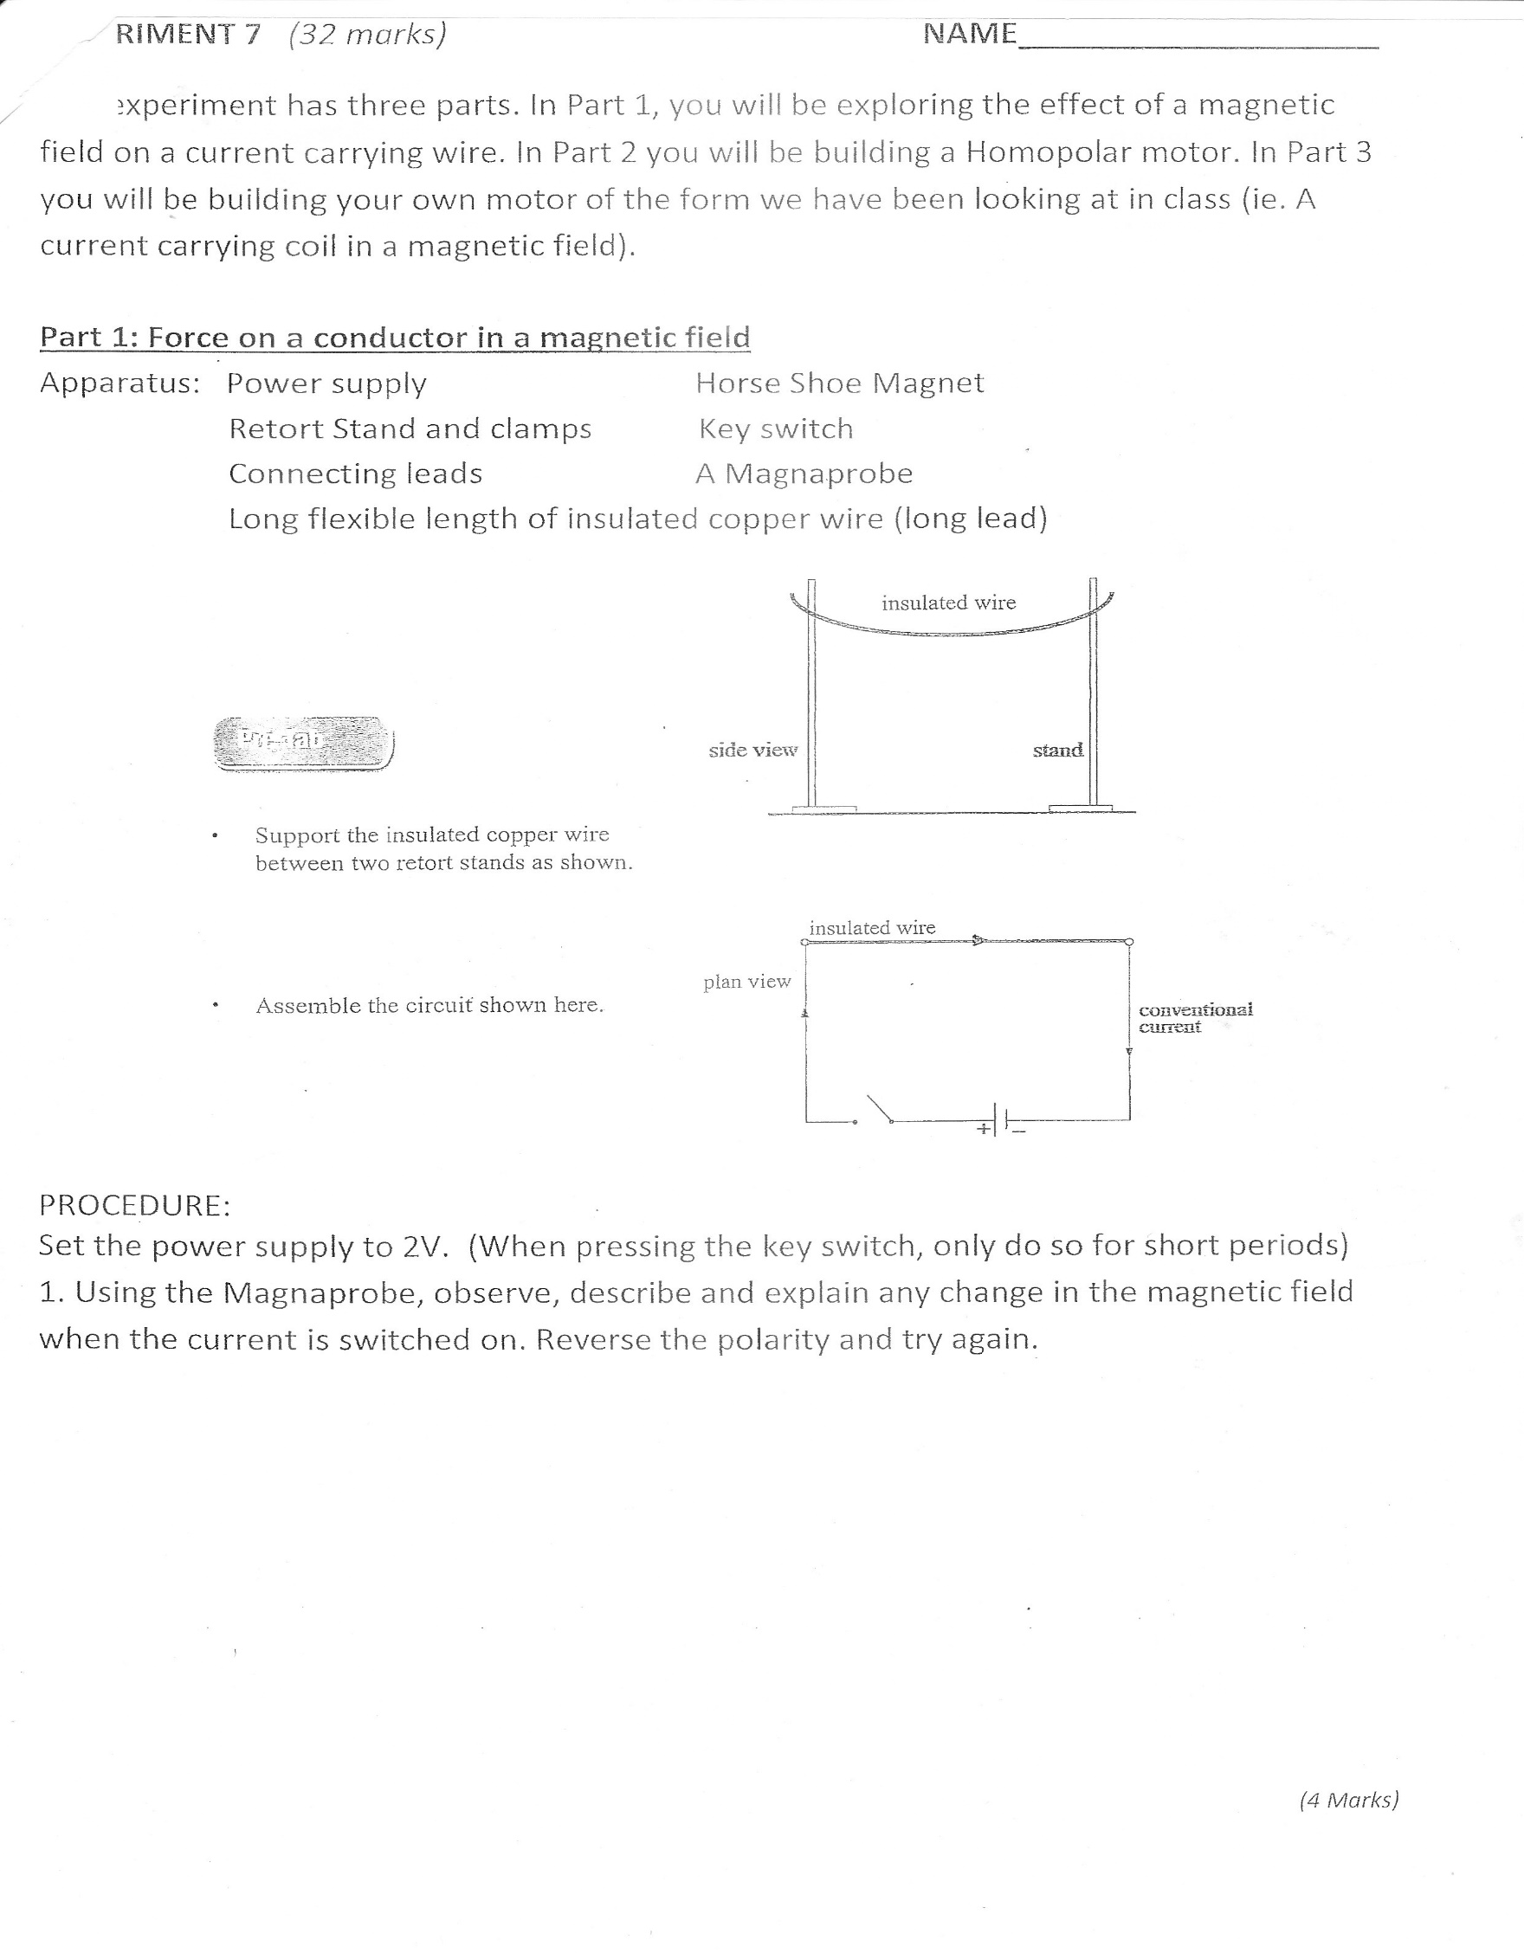Apparatus: Power supply Horse Shoe Magnet

Retort Stand and clamps Key switch

2 x Long leads Magna Probe

Support the insulated copper wire between two retort stands as shown

Assemble the circuit shown.

**PROCEDURE:**

1. Set the power supply to 2V DC. (When pressing the switch, only do so for short periods)

Using the Magna probe to detect the field, draw a diagram to summarise what you observe.

One mark for shape, one for direction

*(2 Marks)*

2. Now change the power supply to 2V AC. Explain what you now observe with the magnaprobe.

No observed change in field, but the field will be constantly changing as the direction of the current changes. *✓* This happens at 50 Hz which is too fast for the magnaprobe to respond to. *✓*

*(2 Marks)*

3. Explain why you were instructed to hold the switch down only for a short period of time.

There is very little resistance in the circuit so the current is large. *✓*

A large current can burn components. *✓*

*(2 Marks)*

**Constructing a Homopolar Motor**

Apparatus: One screw

One AA battery

One neodymium magnet

One short length of copper wire with ends exposed

Procedure: Connect the apparatus as shown:

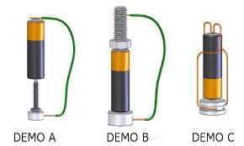

1. Describe what happens, if anything, when:

a) the bottom of the wire touches the screw and not the magnet

*Nothing happens ✓*

b) the bottom of the wire touches the side of the magnet

*Screw spins quickly ✓*

*(2 Marks)*

2. Explain why it happens (*hint: the motor works when the wire touches the side of the magnet. It would not work if the wire touched the centre bottom of the magnet - try it. Nor will it work if the wire touches the screw and not the magnet)*

c) the bottom of the wire touches the centre bottom of the magnet.

*Nothing happens ✓*

*(3 Marks)*

2. Based on your observations, explain how and why the homopolar motor works (it will require some thought). Include a diagram in your explanation.

Diagram showing current flow and field *✓*

Current creates own field *✓*

Field of current interacts with field of magnet resulting in force *✓*

T=Fr (radius is distance from centre of magnet – no radius, no spin) *✓✓*

Or

F=BIL (No radius=no L)

I

| r |

*(5 Marks)*

**Building a DC Coil Motor**

APPARATUS: 1 m of “lacquered” wire Masking tape

Sandpaper 2 Banana/Alligator leads

White Plastic Container Power supply

2 short lengths (copper wire) 1 DC Power Supply

1 pair needle nose pliers 1 bar magnet

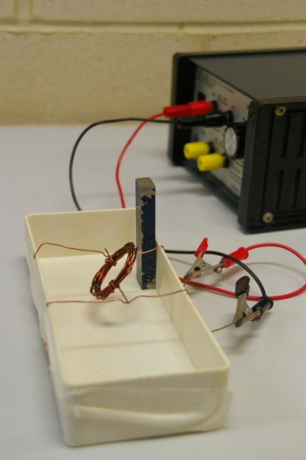PROCEDURE:

1. Tape the two bits of copper wire across your container approximately 5 cm apart (you may like to make an indent in the wire with the pliers to hold the axle of the coil)

2. Make a coil out of the lacquered wire by wrapping the wire around the D Cell battery. Secure the coil by wrapping the

ends around the wire and leaving a tail on each side.

Coil

The tails act as the axle which bridges the two

Tail

pieces of copper wire. Tail

3. Sand all of the lacquer off 1 tail, and sand the lacquer off one side of the other tail.

4. Connect the two lengths of copper wire to the power supply (2V), and with the help of the bar magnet, get your motor to work.

QUESTIONS:

1. Demonstrate your motor in operation to your teacher

*(2 Marks)*

2. Explain why it is important to use lacquered wire for the coil.

The lacquer acts as insulation. *✓*

Without it the current will cut across the strands of the coil and the motor will not work. *✓*

*(2 Marks)*

2. Explain how and why the DC coil motor of part 3 works. Include in your explanation how the design overcomes the need for a commutator. Also include a diagram.

Current in coil creates own field *✓*

Field interacts with that of permanent magnet creating Force *✓*

Force causes coil to spin to rotate part way *✓*

Tail that is only half sanded causes current to switch off at this point *✓*

Momentum carries coil around 180ᵒ *✓*

Current starts again and coil rotated another 180ᵒ

Switches off – cycle continues *✓*

One for diagram showing field. *✓*

*(7 Marks)*